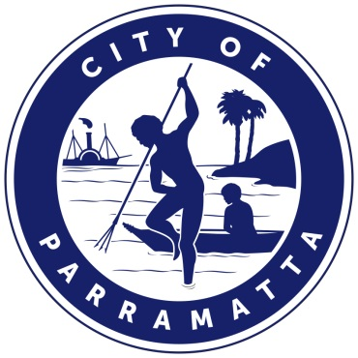

**Planning Proposal**

**10 Valentine Avenue, Parramatta**

**Planning Proposal drafts**

Proponent versions:

|  |  |  |
| --- | --- | --- |
| **No.** | **Author** | **Version** |
|  | Robinson Urban Planning | June 2018 |
|  | Robinson Urban Planning | October 2018 |

Council versions:

|  |  |  |
| --- | --- | --- |
| **No.** | **Author** | **Version** |
|  | City of Parramatta Council | February 2019 version forwarded to the Department of Planning and Environment seeking Gateway determination |

Contents

INTRODUCTION 4

**Background and context** 4

PART 1 – OBJECTIVES OR INTENDED OUTCOMES 5

PART 2 – EXPLANATION OF PROVISIONS 5

**2.1** **Other relevant matters** 5

PART 3 – JUSTIFICATION 6

**3.1** **Section A - Need for the planning proposal** 6

**3.2** **Section B – Relationship to strategic planning framework** 6

**3.3** **Section C – Environmental, social and economic impact** 21

**3.4** **Section D – State and Commonwealth Interests** 22

PART 4 – MAPPING 22

**4.1** **Existing controls** 23

**4.2** **Proposed controls** 28

PART 5 – COMMUNITY CONSULTATION 30

PART 6 – PROJECT TIMELINE 30

Appendix 1 – Draft site-specific clause 31

Appendix 2 – Urban Design Report 32

Appendix 3 – Draft site-specific Development Control Plan 33

# **INTRODUCTION**

This planning proposal explains the intended effect of, and justification for, the proposed amendment to *Parramatta Local Environmental Plan 2011.*  It has been prepared in accordance with Section 3.33 of the *Environmental Planning and Assessment Act 1979* and the Department of Planning and Environment (DP&E) guides, 'A Guide to Preparing Local Environment Plans' (August 2016) and 'A Guide to Preparing Planning Proposals' (August 2016) and ‘Guidance for merged councils on planning functions’ (May 2016).

## **Background and context**

A Planning Proposal for land at 10 Valentine Avenue, Parramatta was lodged by the applicant, Investa Office Developments seeking an increase in the permissible density through amendments to the height and floor space ratio controls. The legal property description of the site is Lot 2 Stratum Plan 1119257 and the site area is 3,935 sqm. The site is shown in Figure 1 below.

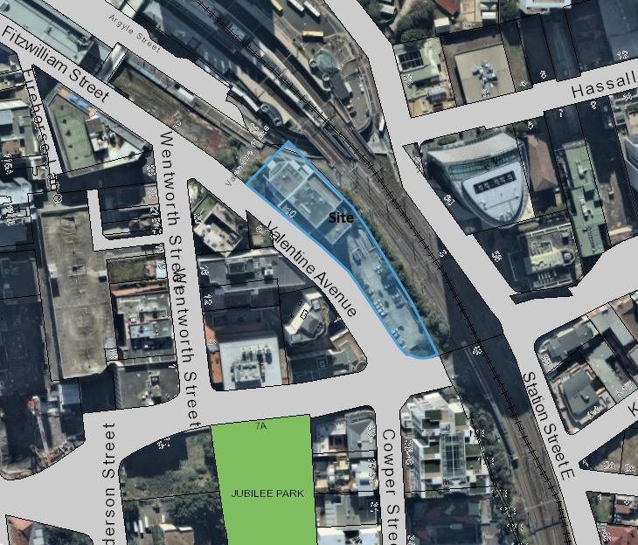

**Figure 1** – Site at 10 Valentine Avenue, Parramatta subject to the Planning Proposal

The site contains a commercial building within the northern part of the site and a multi-storey car park within the southern part of the site (Refer to **Figure 2** below). The applicant proposes to retain the existing commercial building and develop the southern part of the site containing the existing car park

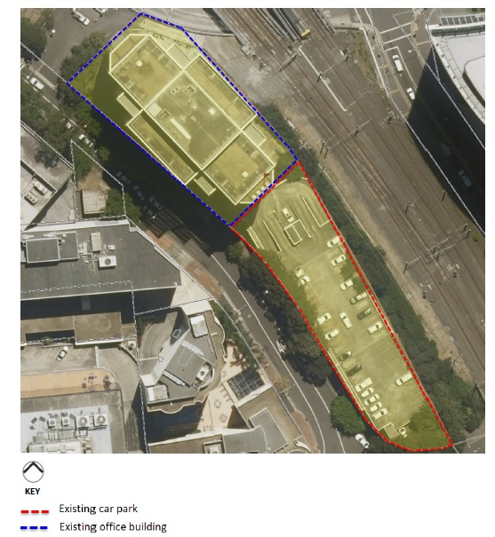

**Figure 2** - Aerial photo showing existing building to the north proposed to be retained and existing car park to the south proposed to be redeveloped.

Under the Parramatta Local Environmental Plan 2011,the site:

* is zoned Commercial Core B3;
* has a maximum building height of 54 metres;
* has a maximum floor space ratio (FSR) of 6:1;
* The site is not listed as an item of heritage significance and is not within a Heritage Conservation Area. The site is near the Parramatta Railway Station which is listed as an item of State heritage significance and is also listed on the State Heritage Register.
* The southern tip of the site is subject to the 1 in 100 year Average Recurrence Interval flood level and the southern end of the site is subject to the Probable Maximum Flood level.

An extract of each the above maps is provided in Part 4 – Mapping; specifically, Section 4.1 Existing controls.

# **PART 1 – OBJECTIVES OR INTENDED OUTCOMES**

The objective of this planning proposal is to increase the permissible density of the land at 10 valentine Avenue, Parramatta so as to encourage the urban renewal of the site in accordance with the site’s B3 Commercial Core zoning.

# **PART 2 – EXPLANATION OF PROVISIONS**

This planning proposal seeks to amend *Parramatta LEP 2011* (*PLEP 2011*) in relation to the height and floor space ratio controls.

In order to achieve the desired objectives the following amendments to the *PLEP 2011* would need to be made:

1. Amend the Height of Buildings Map (Sheet HOB_010) to remove the 54 metre height standard that applies to part of the site. Refer to Figure 13 in this Planning Proposal.
2. Amend the Floor Space Ratio Map (Sheet FSR_010) to increase the FSR standard from 6:1 to 10:1. Refer to Figure 14 in this Planning Proposal.

(Note: a 15% bonus for FSR is provided for by the existing Design Excellence Cluse in PLEP 2011 (cl. 7.10(8))

1. Amend the Special provisions Area Map (SPA_001) to show the site as Area X (number to be allocated prior to finalisation) and insert a site-specific clause that:
   * Replicates the Parramatta CBD Planning Proposal clause that exempts office development from any FSR standards;
   * Prevents the granting of development consent for subdivision of above ground car parking; and
   * Applies the maximum car parking rates endorsed as part of the CBD Planning Proposal.

(Refer to Appendix 1 for suggested wording of these clauses).

## **Other relevant matters**

* + 1. **Draft DCP**

Council resolved to prepare and exhibit a site-specific DCP which provides for a maximum podium height at 25.0 metres AHD in accordance with the existing development consent (DA/841/2017). The DCP will also require the footpath design to be capable of being narrowed if Valentine Avenue is converted to two-way traffic in the future.

* + 1. **Design Competition and Development Consent**

The site has been subject to a previous Design Competition Design Competition in 2017 under the existing Design Excellence provisions of the PLEP 2011. The Design Competition was predicated on the basis of a Scheme 1 and Scheme 2 design. Scheme 1 reflects the existing PLEP 2011 controls in relation to height and FSR and Scheme 2 reflects the proposed controls endorsed by Council under the CBD Planning Proposal. The applicant’s intention was to proceed with construction based on Scheme 1 design (which also has DA approval) and to follow up with a further application to add additional floors to the building under the Scheme 2 design upon finalisation of the CBD Planning Proposal.

The Design Jury awarded design excellence to the preferred scheme in August 2017 which was a design by Fitzpatrick + Partners. **Figures 3 and 4** below show Scheme 1 and Scheme 2 of the winning design.

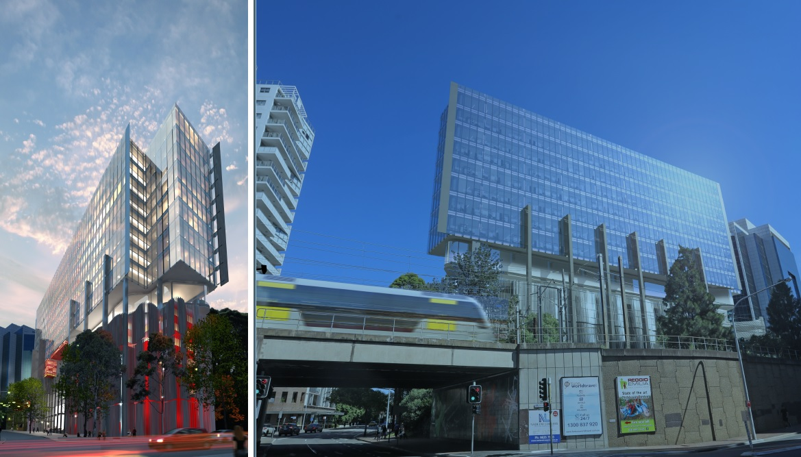

**Figure 3**: Scheme 1 of the winning design reflecting existing PLEP 2011 controls (FSR of 6.9:1 and HOB of 62.1m including Design Excellence Bonus) (Source: Applicant’s Design Competition submission, Fitzpatrick + Partners)

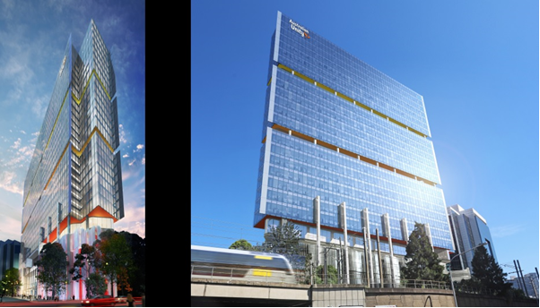

**Figure 4**: Scheme 2 of the winning design reflecting CBD Planning Proposal controls (FSR of 11.19:1 and HOB of 116.2m including Design Excellence Bonus). (Source: Applicant’s Design Competition Submission, Fitzpatrick + Partners)

A Development Application (DA/841/2017) was subsequently approved on 10 April 2018 which relates to a 14-storey building in accordance with Scheme 1 of the Design Competition winning design. Should the Planning Proposal proceed, the applicant would require further development consent in order to develop in accordance with Scheme 2 of the winning design.

# **PART 3 – JUSTIFICATION**

This part describes the reasons for the proposed outcomes and development standards in the planning proposal.

## **Section A - Need for the planning proposal**

* + 1. **Is the Planning Proposal a result of any study or report?**

This Planning Proposal is not the result of any site specific study or report and is in response to an owner-initiated Planning Proposal. However, the Planning Proposal is consistent with the proposed floor space ratio adopted by Council for the site as part of the Parramatta CBD Planning Proposal.

The CBD Planning Proposal stems from local and State government strategic plans including the NSW Government’s *A Plan for Growing Sydney*, Parramatta City Centre Vision 2007 and Parramatta CBD Planning Strategy. Notably, *A Plan for Growing Sydney* states the Government will work with Parramatta Council to review expansion opportunities in the Parramatta CBD including updated building height controls and removal of barriers to growth to promote more efficient land use outcomes.

Consistently, these plans highlight Parramatta’s role as Sydney’s second CBD and as a key area for future development to cater for projected increases in the residential and working population of the region.

* + 1. **Is the Planning Proposal the best means of achieving the objectives or intended outcomes, or is there a better way?**

A planning proposal seeking to amend the *Parramatta LEP 2011* is the most effective way of providing certainty for Council, the local community and the landowner and allows for orderly and economic development of the land. The existing height and FSR standards would not permit part of the form of development envisaged in the planning proposal and would not allow the site to capitalise on its location within the Parramatta CBD.

## **Section B – Relationship to strategic planning framework**

This section assesses the relevance of the Planning Proposal to the directions outlined in key strategic planning policy documents. Questions in this section consider state and local government plans including the NSW Government’s Greater Sydney Region Plan - A Metropolis of Three Cities and the Central City District Plan, State Environmental Planning Policies, local strategic and community plans and applicable Ministerial Directions.

* + 1. **Is the planning proposal consistent with the objectives and actions contained within the applicable regional or sub-regional strategy?**

**Greater Sydney Region Plan**

On March 2018, the Greater Sydney Region Plan (the ‘Plan’) was finalised by the Greater Sydney Commission. The adoption of the Greater Sydney Region Plan will supersede A Plan for Growing Sydney as Sydney’s overarching metropolitan strategy.

The vision of this Plan is built on the three cities concept where residents live within 30 minute access to jobs, education and health facilities, services and places. This is consistent with the 10 Directions as set in Directions for a Greater Sydney, which is the core component of the vision and measure of the Plan’s performance.

The Plan identifies that a target of an additional 725,000 dwellings would be needed within the Greater Sydney Region by 2036 to meet housing demands based on current population growth.

The Greater Sydney Region Plan is structured around four key themes—infrastructure and collaboration, liveability, productivity and sustainability—and sets out a number of directions, objectives and actions to guide delivery of these themes.

The tables below provides a summary of the consistency of the proposal with the relevant

directions and objectives.

***Infrastructure and Collaboration***

An assessment of the planning proposal’s consistency with the GSRP’s relevant Infrastructure and Collaboration objectives is provided in Table 3a, below.

**Table 3a –**  Consistency of planning proposal with relevant GSRP Actions – Infrastructure and Collaboration

|  |  |  |
| --- | --- | --- |
| **Infrastructure and Collaboration Direction** | **Relevant Objective** | **Comment** |
| **A city supported by infrastructure** | **O1:** Infrastructure supports the three cities | The Planning Proposal will facilitate an increase in A-Grade office space and therefore jobs within the Commercial Core of Parramatta CBD on a site that adjoins the Parramatta Transport Interchange giving workers access to train and bus services. |
| **O2:** Infrastructure aligns with forecast growth – growth infrastructure compact | The Planning Proposal will facilitate growth in commercial floor space and hence growth in jobs within the GPOP area which is being trialed as the pilot growth infrastructure compact. |
| **O4:** Infrastructure use is optimised | In accordance with the Objective 4, the planning proposal will allow for efficient land use by locating new office and commercial spaces in the vicinity of Parramatta railway station and future Parramatta Light Rail network. Future occupants and users of the site will have access to the existing and proposed transport infrastructure and will benefit from the commuting advantages. |

***Liveability***

An assessment of the planning proposal’s consistency with the GSRP’s relevant Liveability objectives is provided in Table 3b, below.

**Table 3b –**  Consistency of planning proposal with relevant GSRP Actions – Liveability

|  |  |  |
| --- | --- | --- |
| **Liveability Direction** | **Relevant Objective** | **Comment** |
| **A city of great places** | **O12:** Great places that bring people together | The development concept includes a ground floor lobby incorporating public art and a café addressing Valentine Avenue which will support further activation of Valentine Avenue. |

***Productivity***

An assessment of the planning proposal’s consistency with the GSRP’s relevant Productivity objectives is provided in Table 3c, below.

**Table 3c –**  Consistency of planning proposal with relevant GSRP Actions – Productivity

|  |  |  |
| --- | --- | --- |
| **Productivity Direction** | **Relevant Objective** | **Comment** |
| **A well connected city** | **O14:** The plan integrates land use and transport creates walkable and 30 minute cities | The planning proposal satisfies this direction by co-locating commercial spaces on a site that is within walking distance to Parramatta Railway Station and the proposed Parramatta Light Rail Station; and will uphold the concept of a 30-minute city. |
| **O15:** The Eastern, GPOP and Western Economic Corridors are better connected and more competitive | The Planning Proposal increases the permissible density on the site which will allow for an increase in commercial floor space, further strengthening the commercial core of Parramatta and reinforcing its role in the GPOP area. |
| **Jobs and skills for the city** | **O19**: Greater Parramatta is stronger and better connected | The outcome of the planning proposal will contribute to the economic growth of Parramatta CBD and enables a mixture of commercial uses directly next to a key public transport infrastructure.  This proposal will provide improvements to the site that will enhance the vibrancy, competiveness and walkability within Parramatta CBD. |
| **O22**: Investment and business activity in centres | The Planning Proposal will facilitate an increase in A-grade office space and jobs on a commercial site adjacent the Parramatta Transport Interchange, integrating land use and transport . consistent with this direction and objective. For the Central River City, the plan projects that 65% of residents would access the city within 30 minutes. Increasing jobs in the Parramatta CBD, as facilitate by this Planning Proposal, will contribute to achieving this 30 minute city goal. |

***Sustainability***

An assessment of the planning proposal’s consistency with the GSRP’s relevant Sustainability objectives is provided in Table 3d, below.

**Table 3d –**  Consistency of planning proposal with relevant GSRP Actions – Sustainability

|  |  |  |
| --- | --- | --- |
| **Productivity Direction** | **Relevant Objective** | **Comment** |
|  | **O30**: Urban tree canopy cover is increased | The entire site is currently built-up with an existing car parking structure. The development concept will result in a new commercial building with a similar footprint to the existing structure. As such, there is no opportunity for tree planting onsite. However, the development concept includes the use of green walls on a portion of the building and retention of existing street trees within the public domain on Valentine Avenue. |
| An efficient city | **O33**: A low-carbon city contributes to net-zero emissions by 2050 and mitigates climate change | The reference design that accompanies the Planning Proposal claims to achieve the following:  Green Star 5 star  NABERS Energy: 5 star  NABERS Water: 4 star  The matter will be further assessed during the Design Competition and Development Application stage. |
| **O34**: Energy and water flows are captured, used and re-used |
| **O35**: More waste is re-used and recycled to support the development of a circular economy |
| A resilient city | **O36**: People and places adapt to climate change and future shocks and stresses | The southern tip of the site is subject to the 1 in 100 year Average Recurrence Interval flood level. The issue of flooding was addressed as part of the development application where it was noted that the proposed building floor levels and vehicular access points have been designed to be above the relevant flood level. Conditions of consent were imposed on the consent (DA/841/2017) to ensure the building appropriately responds to flood risk. Similar conditions of consent will be imposed on any future development consent. |
| **O37**: Exposure to natural and urban hazards is reduced |
| **O38**: Heatwaves and extreme heat are managed |

**Central City District Plan**

In March 2018, the NSW Government released *Central City District Plan* whichoutlines a 20 year plan for the Central City District which comprises The Hills, Blacktown, Cumberland and Parramatta local government areas.

Taking its lead from the GSRP, the *Central City District Plan* (“CCDP”) is also structured under four themes relating to Infrastructure and Collaboration, Liveability, Productivity and Sustainability. Within these themes are Planning Priorities which are each supported Action. Those Planning Priorities and Actions relevant to this planning proposal are discussed below.

***Infrastructure and Collaboration***

An assessment of the planning proposal’s consistency with the CCDP’s relevant Infrastructure and Collaboration Priorities and Actions is provided in Table 4a, below.

**Table 4a –**  Consistency of planning proposal with relevant CCDP Actions – Infrastructure and Collaboration

|  |  |  |
| --- | --- | --- |
| Infrastructure and Collaboration Direction | Planning Priority/Action | Comment |
| **A city supported by infrastructure**  **O1:** Infrastructure supports the three cities  **O2:** Infrastructure aligns with forecast growth – growth infrastructure compact  **O3:** Infrastructure adapts to meet future need  **O4:** Infrastructure use is optimised | **PP C1: Planning for a city supported by infrastructure**   * **A1:** Prioritise infrastructure investments to support the vision of *A metropolis* * **A2:** Sequence growth across the three cities to promote north-south and east-west connections * **A3**: Align forecast growth with infrastructure * **A4:** Sequence infrastructure provision using a place based approach * **A5**: Consider the adaptability of infrastructure and its potential shared use when preparing infrastructure strategies and plans * **A6**: Maximise the utility of existing infrastructure assets and consider strategies to influence behaviour changes to reduce the demand for new infrastructure, supporting the development of adaptive and flexible regulations to allow decentralised utilities | The planning proposal will allow for efficient land use by locating new office and commercial spaces in the vicinity of Parramatta railway station and future Parramatta Light Rail network. Future occupants and users of the site will have access to the existing and proposed transport infrastructure and will benefit from the commuting advantages. |

***Liveability***

An assessment of the planning proposal’s consistency with the CCDP’s relevant Liveability Prioirties and Actions is provided in Table 4b, below.

**Table 4b –**  Consistency of planning proposal with relevant CCDP Actions – Liveability

|  |  |  |
| --- | --- | --- |
| Liveability Direction | Planning Priority/Action | Comment |
| **O7**: Communities are healthy, resilient and socially connected  **O8**: Greater Sydney’s communities are culturally rich with diverse neighbourhoods  **O9**: Greater Sydney celebrates the arts and supports creative industries and innovation | **PP C4: Working through collaboration**   * **A10:** Deliver healthy, safe and inclusive places for people of all ages and abilities that support active, resilient and socially connected communities by (a-d). * **A14:** Facilitate opportunities for creative and artistic expression and participation, wherever feasible with a minimum regulatory burden including (a-c). * **A15:** Strengthen social connections within and between communities through better understanding of the nature of social networks and supporting infrastructure in local places | The development concept includes a ground floor lobby incorporating public art and a café addressing Valentine Avenue which will support further activation of Valentine Avenue. |

***Productivity***

An assessment of the planning proposal’s consistency with the CCDP’s relevant Productivity Priorities and Actions is provided in Table 4c, below.

**Table 4c –**  Consistency of planning proposal with relevant CCDP Actions – Productivity

|  |  |  |
| --- | --- | --- |
| Productivity Direction | Planning Priority/Action | Comment |
| **A well-connected city**  **O19**: Greater Parramatta is stronger and better connected | **PP C7: Growing a stronger and more competitive Greater Parramatta**   * **A23:** Strengthen the economic competitiveness of Greater Parramatta and grow its vibrancy [abridged] * **A26:** Prioritise infrastructure investment [abridged] * **A27:** Manage car parking and identify smart traffic management strategies | The outcome of the planning proposal will contribute to the economic growth of Parramatta CBD and enables a mixture of commercial uses directly next to a key public transport infrastructure.  This proposal will provide improvements to the site that will enhance the vibrancy, competiveness and walkability within Parramatta CBD.  The Planning Proposal includes a site-specific clause that prescribes a maximum car parking rate as identified by the Parramatta CBD Strategic Transport Study. |
| **Jobs and skills for the city**  **O15:** The Eastern, GPOP and Western Economic Corridors are better connected and more competitive | **PP C8: Delivering a more connected and competitive GPOP Economic Corridor**   * **A29**: Prioritise public transport investment to deliver the 30-minute city objective for strategic centres along the GPOP Economic Corridor * **A30**: Prioritise transport investments that enhance access to the GPOP between centres within GPOP | See above  Further, the Planning Proposal will facilitate the redevelopment of the site for commercial office space in the order of between 30,746 sqm and 34,522 sqm. Using Council’s assumed employment generating rate of 1 employee per 24 sqm of floor space, the Planning Proposal has the potential to generate between 1,281 and 1,438 FTE jobs. |
| **O14:** The plan integrates land use and transport creates walkable and 30 minute cities  **O16:** [relevant?] | **PP C9: Delivering integrated land use and transport planning and a 30-minute city**   * **A32**: Integrate land use and transport plans to deliver a 30-minute city * **A33**: Investigate, plan and protect future transport and infrastructure corridors * **A34**: Support innovative approaches to the operation of business, educational and institutional establishments to improve the performance of the transport network * **A36**: Protect transport corridors as appropriate, including the Western Sydney Freight Line, North South train link from Schofields to WS Airport as well as Outer Sydney Orbital and Bells Line of Road-Castlereagh connections | The planning proposal satisfies this direction by co-locating commercial spaces on a site that is within walking distance to Parramatta Railway Station and the proposed Parramatta Light Rail Station; and will uphold the concept of a 30-minute city.  The Planning Proposal acknowledges the location of the PERL Rail Corridor which runs diagonally across the end of the site and impacts on the ability to build a basement under the site. As such, the reference design which accompanies the Planning Proposal incorporates above ground car parking. |

***Sustainability***

An assessment of the planning proposal’s consistency with the CCDP’s relevant Productivity Priorities and Actions is provided in Table 4d, below.

**Table 4d –**  Consistency of planning proposal with relevant CCDP Actions – Sustainability

|  |  |  |
| --- | --- | --- |
| Sustainability Direction | Planning Priority/Action | Comment |
| **O30**: Urban tree canopy cover is increased  **O32**: The Green grid links Parks, open spaces, bushland and walking and cycling paths | **PP C16: PP C16: Increasing urban tree canopy cover and delivering Green grid connections**   * **A68**: Expand urban tree canopy in the public realm | The entire site is currently built-up with an existing car parking structure. The development concept will result in a new commercial building with a similar footprint to the existing structure. As such, there is no opportunity for tree planting onsite. However, the development concept includes the use of green walls on a portion of the building and retention of existing street trees within the public domain on Valentine Avenue. |
| **O31:** Public open space is accessible, protected and enhanced | **PP C17: Delivering high quality open space**   * **A71**: Maximise the use of existing open space and protect, enhance and expand public open space by (a-g) [abridged] | The site is subject to existing provisions within PLEP 2011 (Clause 7.4) which protect sun access to Jubliee Park to the south of the site. |
| **O36**: People and places adapt to climate change and future shocks and stresses  **O37**: Exposure to natural and urban hazards is reduced  **O38**: Heatwaves and extreme heat are managed | **PP C20: Adapting to the impacts of urban and natural hazards and climate change**   * **A81**: Support initiatives that respond to the impacts of climate change * **A82**: Avoid locating new urban development in areas exposed to natural and urban hazards and consider options to limit the intensification of development in existing areas most exposed to hazards * **A85**: Consider strategies and measures to manage flash flooding and safe evacuation when planning for growth in Parramatta CBD | The southern tip of the site is subject to the 1 in 100 year Average Recurrence Interval flood level. The issue of flooding was addressed as part of the development application where it was noted that the proposed building floor levels and vehicular access points have been designed to be above the relevant flood level. Conditions of consent were imposed on the consent (DA/841/2017) to ensure the building appropriately responds to flood risk. Similar conditions of consent will be imposed on any future development consent. |

* + 1. **Is the planning proposal consistent with the local council’s Community Strategic Plan or other local strategic plan?**

The following strategic planning documents are relevant to the planning proposal.

**Parramatta 2038 Community Strategic Plan**

Parramatta 2038 is a long term Community Strategic Plan for the City of Parramatta and it links to the long-term future of Sydney. The plan formalises several big and transformational ideas for the City and the region.

The Planning Proposal is considered to meet the strategies and key objectives identified in the plan by allowing for the concentration of housing around transport nodes and contribute towards dwelling targets for NSW.

[**Parramatta CBD Planning Strategy**](http://www.parracity.nsw.gov.au/__data/assets/pdf_file/0005/158810/CBD_Planning_Strategy.pdf)

Council adopted the "[Parramatta CBD Planning Strategy](http://www.parracity.nsw.gov.au/__data/assets/pdf_file/0005/158810/CBD_Planning_Strategy.pdf)" at its meeting of 27 April 2015. The Strategy is the outcome of detailed technical studies which reviewed the current planning framework and also a significant program of consultation with stakeholders and the community. The objectives of the Strategy are as follows:

1. To set the vision for the growth of the Parramatta CBD as Australia's next great city.
2. To establish principles and actions to guide a new planning framework for the Parramatta CBD.
3. To provide a clear implementation plan for delivery of the new planning framework for the Parramatta CBD.

The implementation of the Strategy is via the Parramatta CBD Planning Proposal. The CBD Planning Proposal has been endorsed by Council on 11 April 2016 and has been forwarded to the Department of Planning and Environment to seek a Gateway determination. A Gateway determination was received on 13 December 2018 allowing the CBD Planning Proposal to be exhibited subject to meeting the conditions of the Gateway determination. The Height of Buildings control, FSR control, car parking rates and site specific clause exempting additional office development from the FSR standard, relating to additional commercial floor space is consistent with the provisions within the CBD Planning Proposal.

* + 1. **Is the planning proposal consistent with the applicable State Environmental Planning Policies?**

The following State Environmental Planning Policies (SEPPs) are of relevance to the site (refer to Table 5 below).

**Table 5 –**  Consistency of planning proposal with relevant SEPPs

|  |  |  |
| --- | --- | --- |
| **State Environmental Planning Policies (SEPPs)** | **Consistency:**  **Yes =**   **No =**   **N/A = Not applicable** | **Comment** |
| SEPP No 1 Development Standards | N/A | This SEPP is not applicable to the subject land under Clause 1.9 of the Parramatta LEP 2011. |
| SEPP 4 – Development Without Consent and Miscellaneous Exempt and Complying Development | N/A | This SEPP is not applicable to the subject land under Clause 1.9 of the Parramatta LEP 2011. |
| SEPP 6 – Number of Storeys in a Building | N/A | Standard instrument definitions apply. |
| SEPP No 55 Remediation of Land |  | The subject site has existing Class 4 Acid Sulfate Soils constraints. Council is satisfied the site is suitable for mixed use purposes. The matter can be further resolved through the development application which considers finer details such as building materials and construction methods.  No further contamination issues have been identified. |
| SEPP 60 – Exempt and Complying Development | N/A | This SEPP is not applicable to the subject land under Clause 1.9 of the Parramatta LEP 2011. |
| SEPP 64 – Advertising and Signage | N/A | Not relevant to proposed amendment. May be relevant to future DAs. |
| SEPP No 65 Design Quality of Residential Flat Development | N/A |  |
| SEPP No.70 Affordable Housing (Revised Schemes) | N/A | Not relevant to proposed amendment. |
| SEPP (Affordable Rental Housing) 2009 | N/A | Not relevant to proposed amendment. |
| SEPP (BASIX) 2004 | N/A |  |
| SEPP (Exempt and Complying Development Codes) 2008 |  | May apply to future development of the site. |
| SEPP (Infrastructure) 2007 |  | May apply to future development of the site. |
| Sydney Regional Environmental Plan No 18–Public Transport Corridors | N/A | This SEPP is not applicable to the subject land under Clause 1.9 of the *Parramatta LEP 2011*. |
| Sydney Regional Environmental Plan (Sydney Harbour Catchment) 2005 | N/A | The proposed development is not located directly on the Sydney Harbour Catchment foreshore. Any potential impacts as a result of development on the site, such as stormwater runoff, will be considered and addressed appropriately at DA stage. |
| SEPP (Urban Renewal) 2010 | N/A |  |

* + 1. **Is the planning proposal consistent with applicable Ministerial Directions (s.9.1 directions)**

In accordance with Clause 9.1 of the *EP&A Act 1979* the Minister issues directions for the relevant planning authorities to follow when preparing planning proposals for new LEPs. The directions are listed under the following categories:

* Employment and resources
* Environment and heritage
* Housing, infrastructure and urban development
* Hazard and risk
* Housing, Infrastructure and Urban Development
* Local plan making

The following directions are considered relevant to the subject Planning Proposal.

**Table 6 –** Consistency of planning proposal with relevant Section 9.1 Directions

|  |  |  |
| --- | --- | --- |
| **Relevant Direction** | **Comment** | **Compliance** |
| **1. Employment and Resources** | | |
| Direction 1.1 – Business and Industrial Zones | This Planning Proposal seeks to retain the B3 Commercial Core zoning, and will contribute approximately 30,746 sqm to 1,438 sqm of employment generating land uses. This would equate to between 1,281 and 1,438 FTE jobs. | Yes |
| **2. Environment and Heritage** | | |
| Direction 2.3 - Heritage Conservation | The subject site does not contain a heritage item listed under Schedule 5 of PLEP2011.  The site is near Parramatta Railway Station which is listed heritage item of State Significance. However, these impacts are considered acceptable given the location of the subject site and heritage items in a densely-built CBD context. The density proposed is consistent with the CBD PP, and is therefore consistent with the desired future context of the site. | Yes |
| **3. Housing, Infrastructure and Urban Development** | | |
| Direction 3.4 - Integrating Land Use and Transport | The Planning Proposal is consistent with this direction, in that it:   * will provide additional commercial premises in proximity to existing transport links * makes more efficient use of space and infrastructure by increasing densities on an underutilised site. * Applies car parking rates to the site which are endorsed by Council through the Parrmaatta CBD Strategic transport Study. | Yes |
| **4. Hazard and Risk** | | |
| Direction 4.1 - Acid Sulfate Soils | The site is identified as Class 5 on the Acid Sulfate Soils Map in Parramatta Local Environmental Plan 2011. Acid sulfate soils are generally not found in Class 5 areas however this will be addressed further at the development application stage. | Yes |
| Direction 4.3 - Flood Prone Land | The southern tip of the site is subject to the 1 in 100 year Average Recurrence Interval flood level. The issue of flooding was addressed as part of the development application where it was noted that the proposed building floor levels and vehicular access points have been designed to be above the relevant flood level. Conditions of consent were imposed on the consent (DA/841/2017) to ensure the building appropriately responds to flood risk. Similar conditions of consent will be imposed on any future development consent. | Yes |
| **6. Local Plan Making** | | |
| Direction 6.1 - Approval and Referral Requirements | The Planning Proposal does not introduce any provisions that require any additional concurrence, consultation or referral. | Yes |
| Direction 6.3 - Site Specific Provisions | The objective of this direction is to discourage unnecessarily restrictive site specific planning controls. The Planning Proposal does include site-specific provisions in relation to minimum commercial floor space area and maximum car parking rates. These provisions are included to ensure consistency with Council’s endorsed Parramatta CBD Planning Proposal. | Yes |
| **7. Metropolitan Planning** | | |
| Direction 7.1 - Implementation of A Plan for Growing Sydney | As detailed in this report, the Planning proposal is consistent with the relevant metropolitan plan (Greater Sydney Region Plan, March 2018). | Yes |
| Direction 7.5 – Implementation of Greater Parramatta Priority Growth Area Interim Land Use and Infrastructure Implementation Plan | The proposal is consistent with the actions in the interim Land Use and Infrastructure Plan in that the proposal:   * Is in line with the Parramatta CBD Planning Proposal * Will contribute towards employment targets within the Parramatta City Centre * May assist in the funding of infrastructure should the site be developed for part residential purposes. | Yes |

## **Section C – Environmental, social and economic impact**

This section considers the potential environmental, social and economic impacts which may result from the Planning Proposal.

* + 1. **Is there any likelihood that critical habitat or threatened species, populations or ecological communities, or their habitats, will be adversely affected as a result of the proposal?**

The site is located within a highly modified urban environment and it is very unlikely to contain critical habitat or threatened species, populations or ecological communities, or their habitats.

* + 1. **Are there any other likely environmental effects as a result of the planning proposal and how are they proposed to be managed?**

Reference Design

The reference design that accompanies the Planning Proposal reflects two possible development application scenarios and are titled reference design 1 and reference design 2 (refer to attached Urban Design Report in Attachment 2). It should be noted that reference design 1 and 2 have no relationship to Scheme 1 and 2 of the Design Competition of the winning design. This approach was recommended by Council Officers to transparently communicate to Council and the community the possible approaches to the development that could be taken by the proponent given that a Development Approval has already been granted for the subject site.

**Reference Design 1** reflects a scenario where the applicant proposes to commence building that development approved under the existing development consent (DA/841/2017) and then applies for a development application for additional storeys permitted under the Planning Proposal. The development would then occur under two consents being the original existing consent for the lower floors and the second future consent for the upper floors.

Reference Design 1 proposes:

A 31 storey (120 metre high) freestanding tower comprising:

6 levels of aboveground car parking;

21 levels of commercial floor space providing 30,746 square metres of office space;

3 levels of terrace/end-of-trip facilities and 1 level for plant.

The applicant’s reference design 1 is shown in **Figures 5 and 6** below.

**Reference Design 2** reflects a scenario where the applicant proposes a new building that has no relationship to the building that is subject to the existing development consent. The application would be a new development application as permitted by the Planning Proposal for the entire building. Reference Design 2 proposes:

A thirty-one storey (120 metre high) freestanding tower comprising:

3 levels of above ground car parking;

24 levels of commercial floor space providing 34,522sqm of office space; and

3 levels of terrace/end of trip facilities and 1 level for plant.

The applicant’s reference design 2 is shown in **Figures 7 and 8** below.

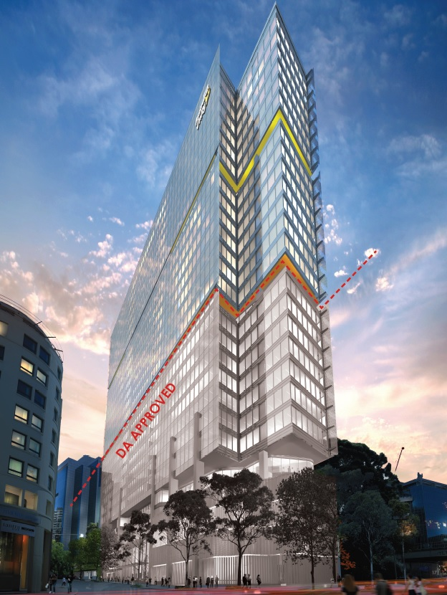

**Figure 5**: Applicant’s design concept (Reference Design 1) when viewed from the south (Source: Applicant’s Urban Design Report, Fitzpatrick + Partners)

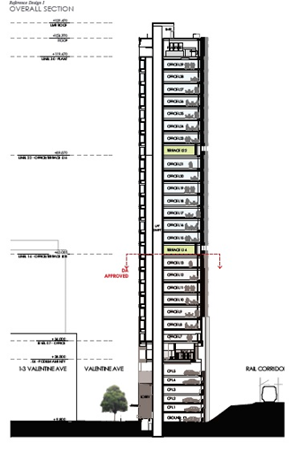

**Figure 6**: Applicant’s Urban Design concept (Reference design 1) east-west section (Source: Applicant’s Urban Design report, Fitzpatrick + Partners).

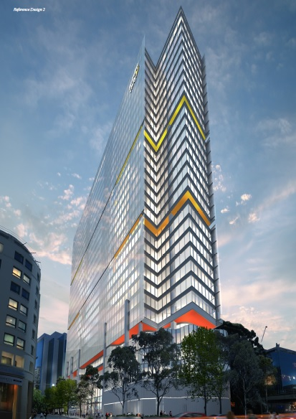

**Figure 7**: Applicant’s design concept (Reference Design 2) when viewed from the south (Source: Applicant’s Urban Design Report, Fitzpatrick + Partners)

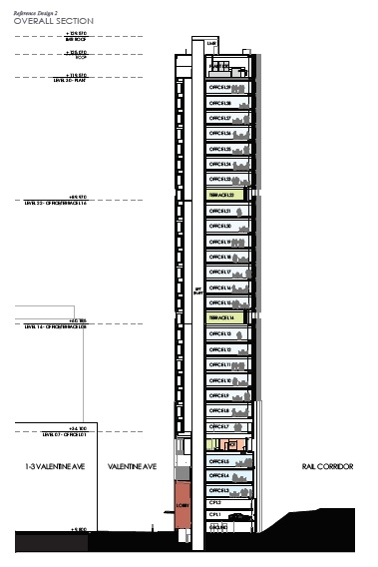

Figure 8: Applicant’s Urban Design concept (Reference design 2) east-west section (Source: Applicant’s Urban Design report, Fitzpatrick + Partners)

Urban Design

With regard to the reference design, concerns were raised with the initial reference design submitted with the Planning Proposal. Council’s City Architect’s team noted that during the course of the assessment of the development application which followed the Design Competition (DA/841/2017) a negotiated position was reached on the following:

1. The floor-to-floor height of the aboveground car parking levels;
2. The number of aboveground car parking levels; and
3. The overall podium height.

The applicant’s Urban Design Report references the DCP podium height control (26 metres above natural ground) as being the relevant benchmark for their site. However, the primary concern with the podium height is the nature of the podium itself which contains car parking.

The Parramatta DCP 2011 seeks to avoid aboveground car parking in the CBD where possible. Where basement car parking is not possible, the aboveground car parking should be sleeved with other uses (ie in this case commercial floor space) to avoid blank walls being presented to the street..

Basement car parking is not practical on this site due to the existence of the Parramatta to Epping Rail Protection Corridor (PERL). This protected corridor may ultimately be used for another infrastructure project, potentially the Sydney Metro West, however, notwithstanding this, the protected corridor precludes the construction of basement car parking for this site. Sleeving is also not possible or practical due to the site’s narrow width.

Given these constraints, it is considered acceptable in this case, for car parking to be provided in the podium. However, the visual impacts of this need to be managed appropriately and minimised. For this reason, the assessment of the development application reached a position where the overall podium height was limited to that of the existing concrete car parking structure (25.0m AHD). This resulted in 6 levels of aboveground car parking in total.

It is noted that if a new development application is lodged in the future that has no relationship to the original consent, a new design competition will be required. As such, it is appropriate to prepare a site-specific DCP to accompany the Planning Proposal that prescribes a maximum podium height of 25.0m AHD as identified through the assessment of the previous development application.

Car parking

The difference between Reference Design 1 and Reference Design 2 relates to the land uses within the podium. The podium for Reference Design 1 consists of 6 levels of aboveground car parking. The podium for Reference Design 2 consists of 3 levels of aboveground car parking and 3 levels of office space.

A table summarising the car parking spaces under different scenarios is provided in Table 2 below.

**Table 7**: Table summarising car parking numbers under the different scenarios

|  |  |  |  |
| --- | --- | --- | --- |
| **Car Parking** | | | |
|  | **Existing Building** | **New Building** | **Total** |
| Existing concrete car park (to be demolished). | 285 |  |  |
| Car parking within existing commercial building (to be retained) | **27** |  |  |
| Reference Design 1 | 27 | 135 | 162 |
| Reference Design 2 | 27 | 41 | 68 |
| *Note: The car parking rates endorsed under the CBD Planning Proposal allow for a total of* ***79*** *car parking spaces.* | | | |

As shown in the table in Table 7 above, Reference Design 1 does not comply with the CBD Planning Proposal in relation to car parking numbers. Reference Design 2 does comply. However, it is acknowledged that there is an approved development application for a building that includes 135 car spaces in the podium, which is relevant to the assessment of the Planning Proposal. It is possible that the applicant may decide to proceed with the approved development application and lodge a second development application for additional storeys above the approved building (Reference Design 1). If construction has already commenced under the existing approval, it would not be preactival to require an amendment to the existing approval to reduce the car parking on site when the Planning Proposal is finalised. The existing approval with the approved parking would remain valid and the new application for additional floor space with no additional parking would be assessed against the controls in place at the time it is lodged.

However, if the current development application is not activated and a new application is lodged for a new building without relying on the original consent (Reference Design 2), the CBD Planning Proposal car parking rates would be applied. As such, Council endorsed the Planning Proposal for the purpose of seeking a Gateway determination, subject to the inclusion of a site-specific clause which applies the maximum car parking rates endorsed as part of the CBD Planning Proposal.

Reference Design 1 provides for 135 car parking spaces (total of **162** car parking spaces when including 27 spaces within the remaining building at 10 Valentine Avenue) which is consistent with existing policy controls. Reference Design 2 provides for 41 car parking spaces (total of **68** car parking spaces when including 27 spaces within the remaining building at 10 Valentine Avenue) which is consistent with the CBD parking rates endorsed by Council under the CBD Planning Proposal.

Traffic and Transport

Council’s Traffic and Transport team note the following:

1. The number of car parking spaces in the proposed building should comply with the maximum car parking rates under the Parramatta CBD Planning Proposal.
2. While Valentine Avenue is currently a one-way street at present, it is possible that there may be interest in converting it to two-way traffic in the future.

With regard to (a) above, this issue is noted and was discussed previously under the heading “Car Parking”. With regard to (b) above, this issue was addressed through the assessment of the development application (DA/841/2017) which imposed a condition of consent which requires resubmission of the drawings prior to construction with the Council retaining the ability to require a narrower footpath area should two-way traffic in Valentine Avenue be considered appropriate in the future.

To assist in the assessment of any future development applications, this requirement is also to be included in a site-specific DCP as follows:

“The design of the footpath should:-

1. Show a narrower footpath if Council has made a decision to make Valentine Avenue a two-way street at the time the public plans are submitted to Council for endorsement; or
2. Designed in a way that facilitates the narrowing of the footpath if Council has not yet finalised its position on whether Valentine Avenue should change to a two way street.”

Heritage

The site is near Parramatta Railway Station which is listed heritage item of State Significance. Council’s Heritage Advisor notes that the Planning Proposal is consistent with the Parramatta CBD Planning Proposal and has raised no objection.

Flooding

The southern tip of the site is subject to the 1 in 100 year Average Recurrence Interval flood level. The issue of flooding was addressed as part of the development application where it was noted that the proposed building floor levels and vehicular access points have been designed to be above the relevant flood level. Conditions of consent were imposed on the consent (DA/841/2017) to ensure the building appropriately responds to flood risk. Any future development consent would be subject to similar conditions.

Overshadowing

Clause 7.4 (Sun Access) of the Parramatta LEP 2011 brings into consideration the sun access plane controls of the Parramatta DCP 2011. This requires development to not overshadow Jubilee Park between 12 pm and 2pm on 22 June. The shadow diagrams submitted by the applicant with the Planning Proposal indicate that the Planning Proposal complies with this requirement.

* + 1. **How has the planning proposal adequately addressed any social and economic effects?**

There is adequate justification for this planning proposal which will facilitate an increase in commercial floor space and an increase in FTE to between 1,281 and 1,438 FTE jobs. The planning proposal will also facilitate the redevelopment of a site currently used as a car park for a more intensive use that is consistent with the Parramatta CBD Planning Strategy.

## **Section D – State and Commonwealth Interests**

* + 1. **Is there adequate public infrastructure for the planning proposal?**

There is adequate justification for this planning proposal which will facilitate a renewal of the employment generating floor space. The commercial components of the development will contribute to the activation of Valentine Avenue and the surrounding area.

The planning proposal will benefit from its location within close proximity of Parramatta railway station and future Parramatta Light Rail network. Future occupants and users of the site will have access to the existing and proposed transport infrastructure and will benefit from the commuting advantages.

* + 1. **What are the views of State and Commonwealth public authorities consulted in accordance with the gateway determination?**

Consultation with the State and Commonwealth public authorities will be undertaken once the gateway determination has been issued.

# **PART 4 – MAPPING**

This section contains the mapping for this planning proposal in accordance with the DP&E’s guidelines on LEPs and Planning Proposals.

## **Existing controls**

This section illustrates the current *PLEP 2011* controls which apply to the site.

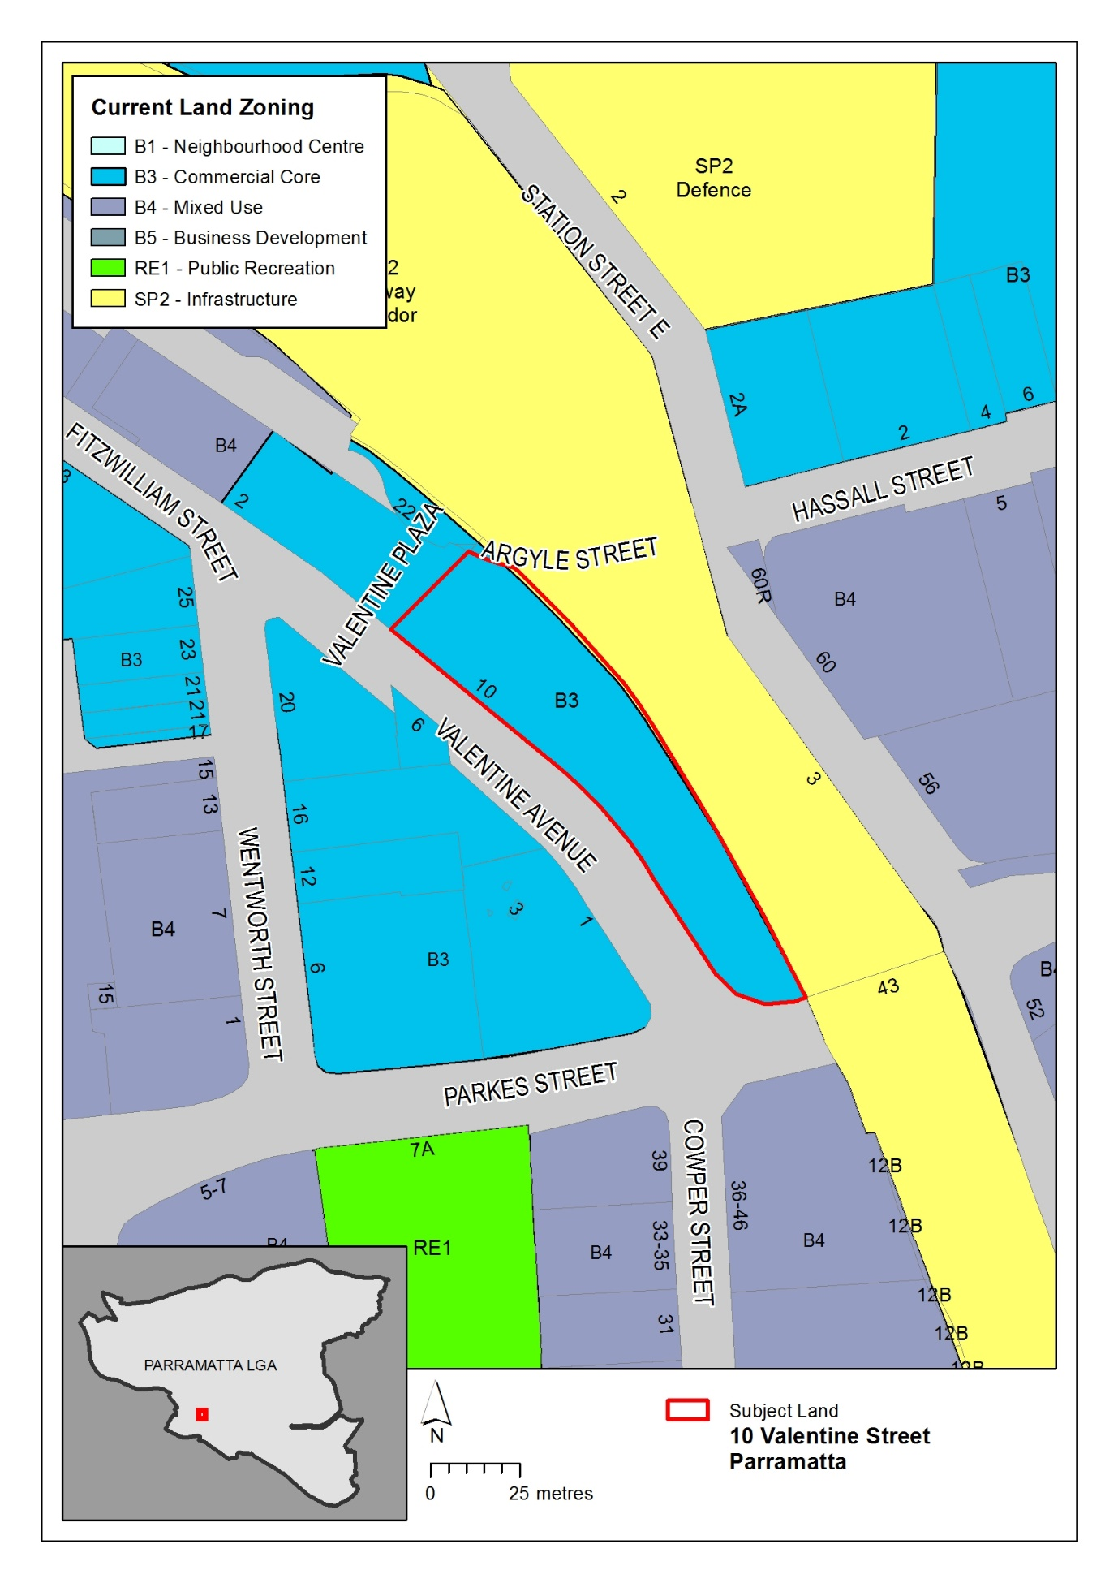

**Figure 9 –** Existing zoning extracted from Parramatta LEP 2011 Land Zoning Map

Figure 9 illustrates the existing B3 Commercial Core zone over the site.

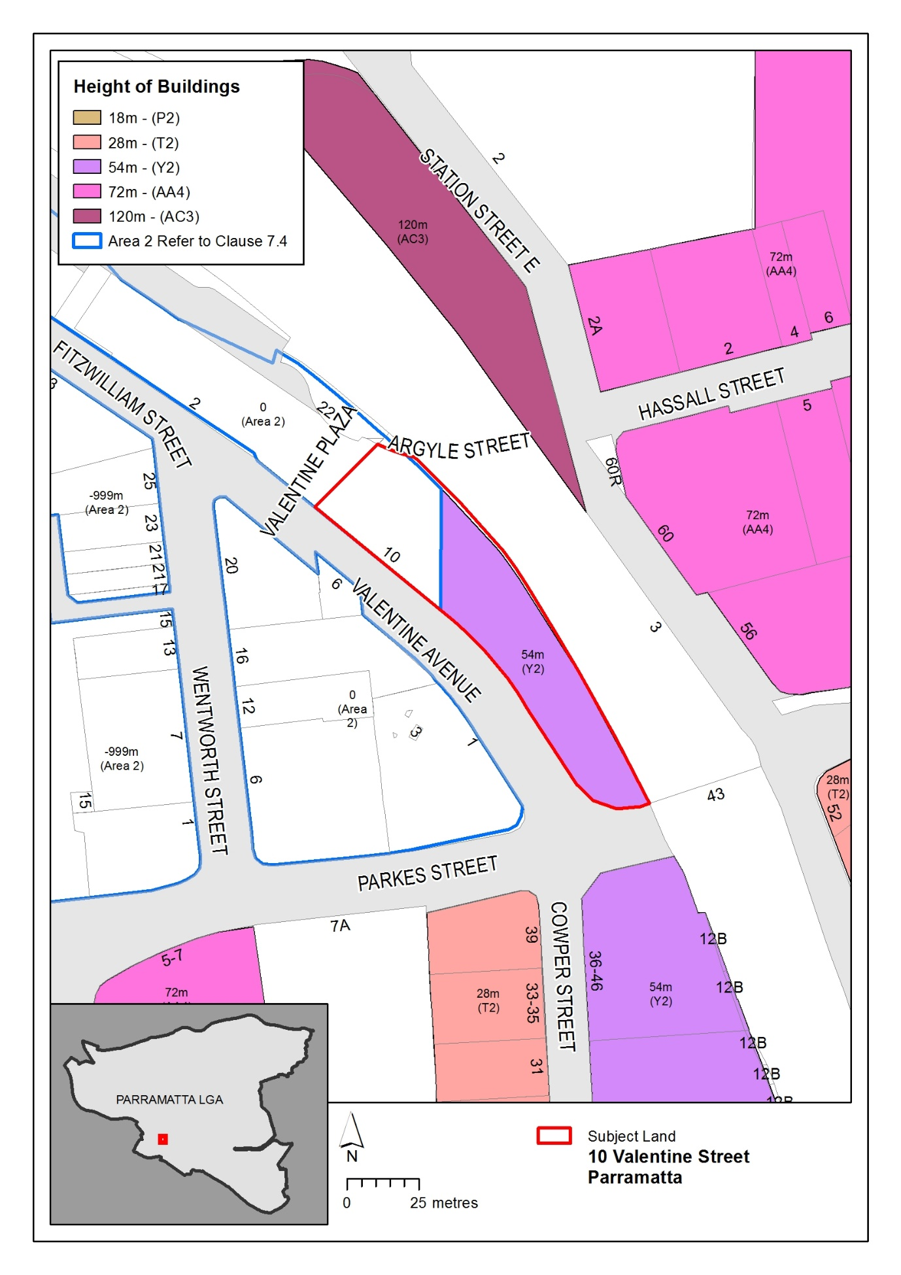**Figure 10 –** Existing building heights extracted from the Parramatta LEP 2011 Height of Buildings Map

Figure 10 illustrates the existing 54 metre height controls over the site. Note, the northern part of the site is affected by Clause 7.4 Sun Access.

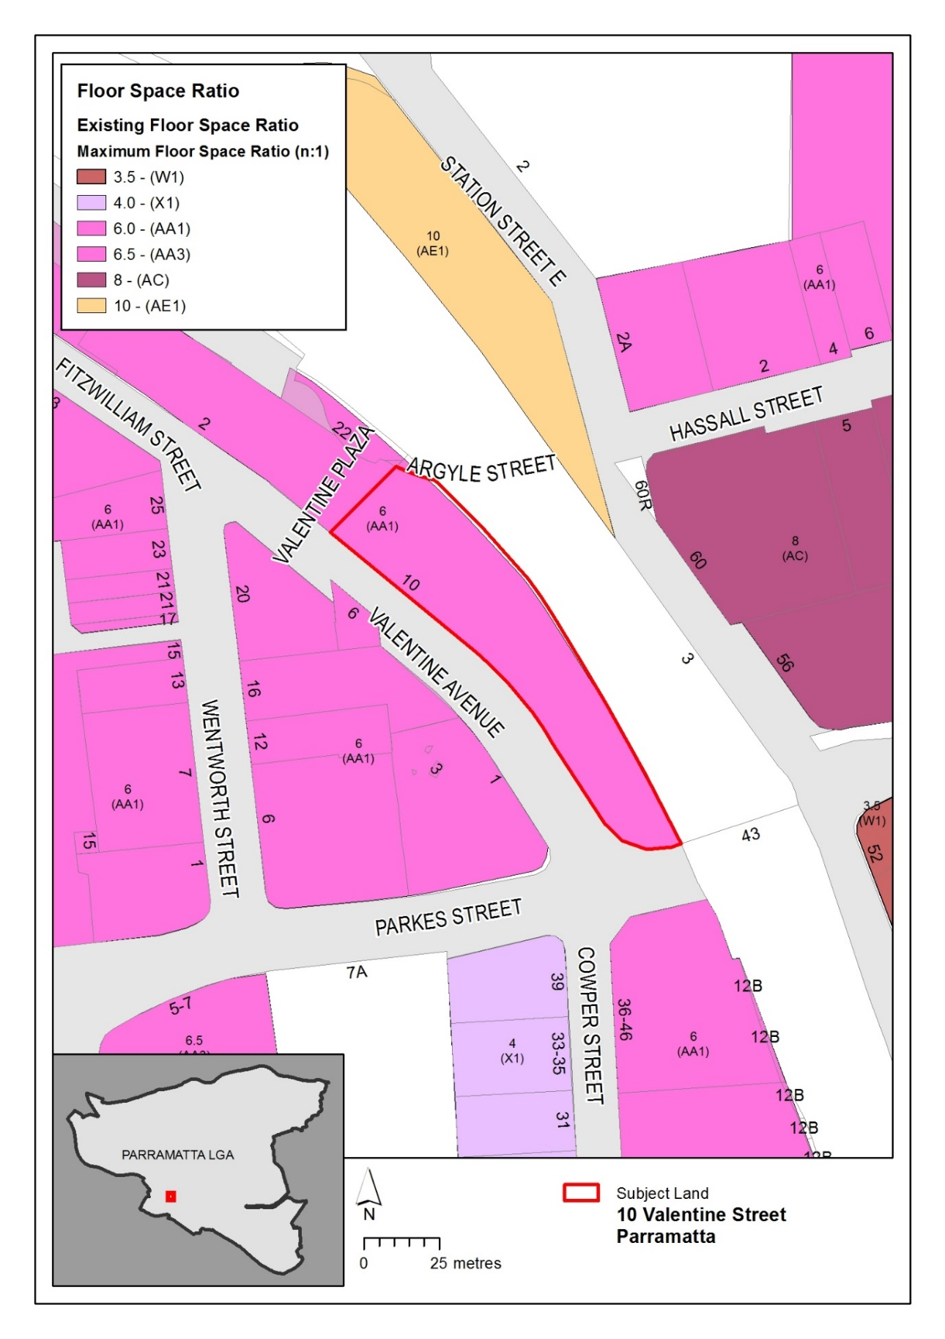

**Figure 11 –** Existing floor space ratio extracted from the Parramatta LEP 2011 Floor Space Ratio Map

Figure 11 illustrates the existing FSR of 6:1 over the site.

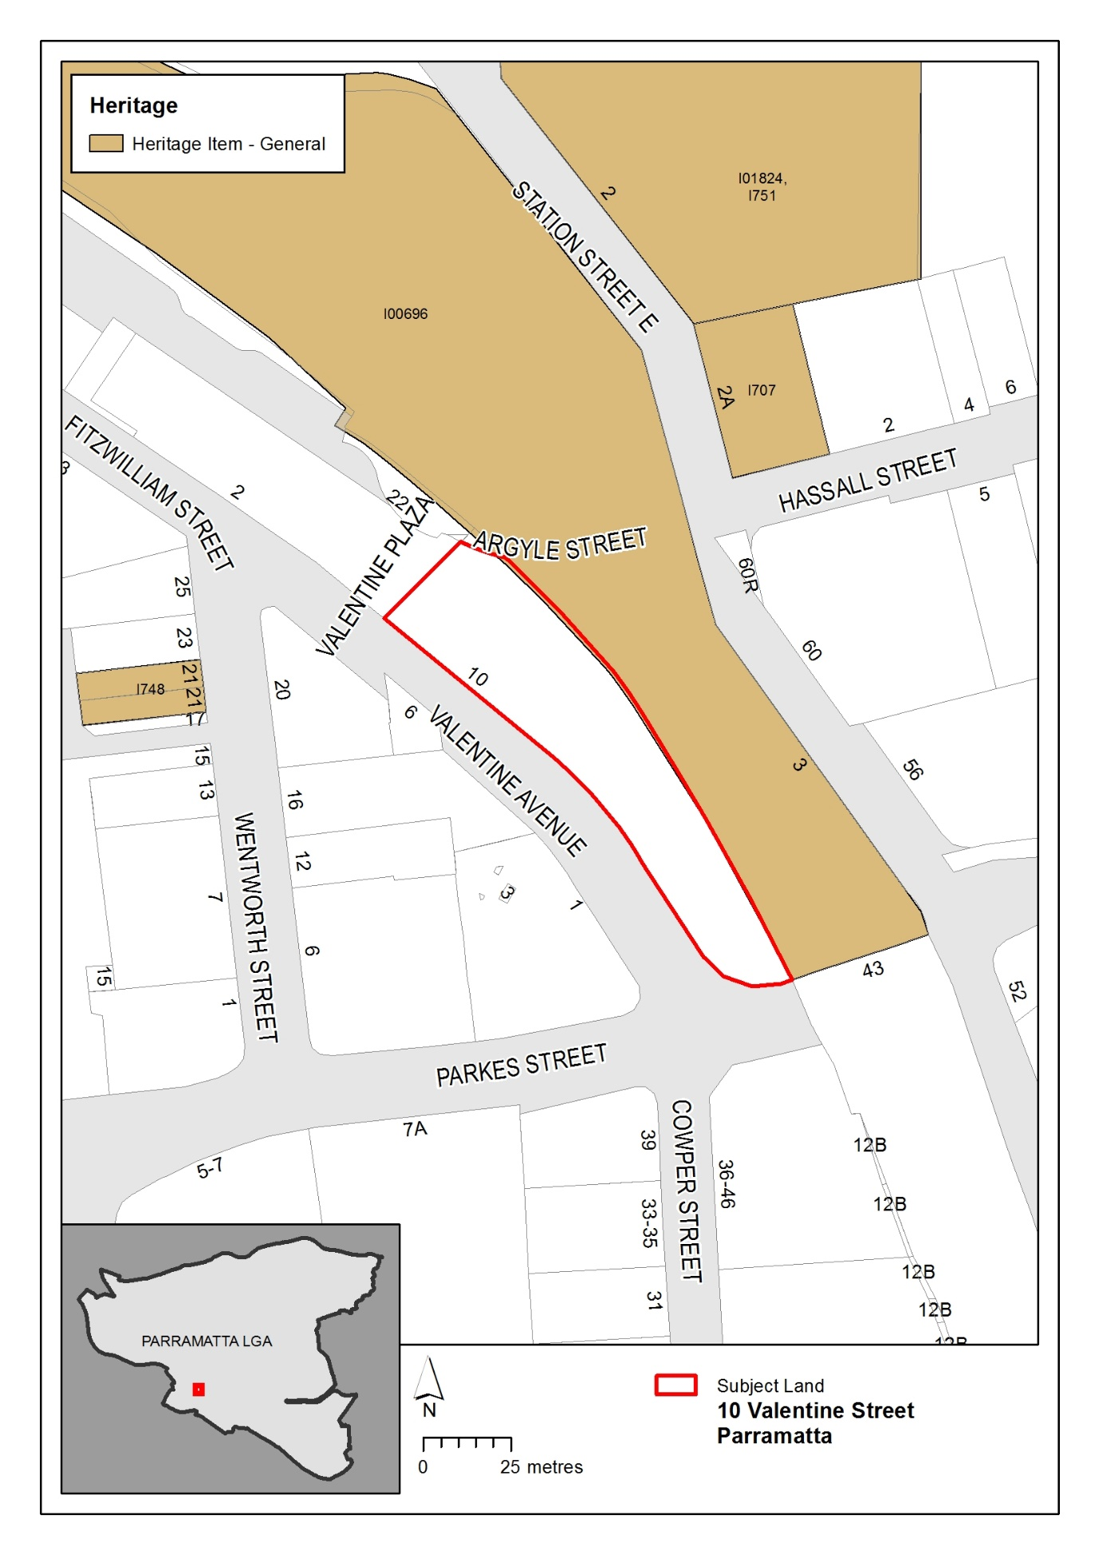**Figure 12 –** Existing heritage items extracted from the Parramatta LEP 2011 Heritage Map

Figure 12 above illustrates the heritage items within proximity of the site.

## **Proposed controls**

The figures in this section illustrate the proposed mapping amendments to Parramatta LEP 2011.

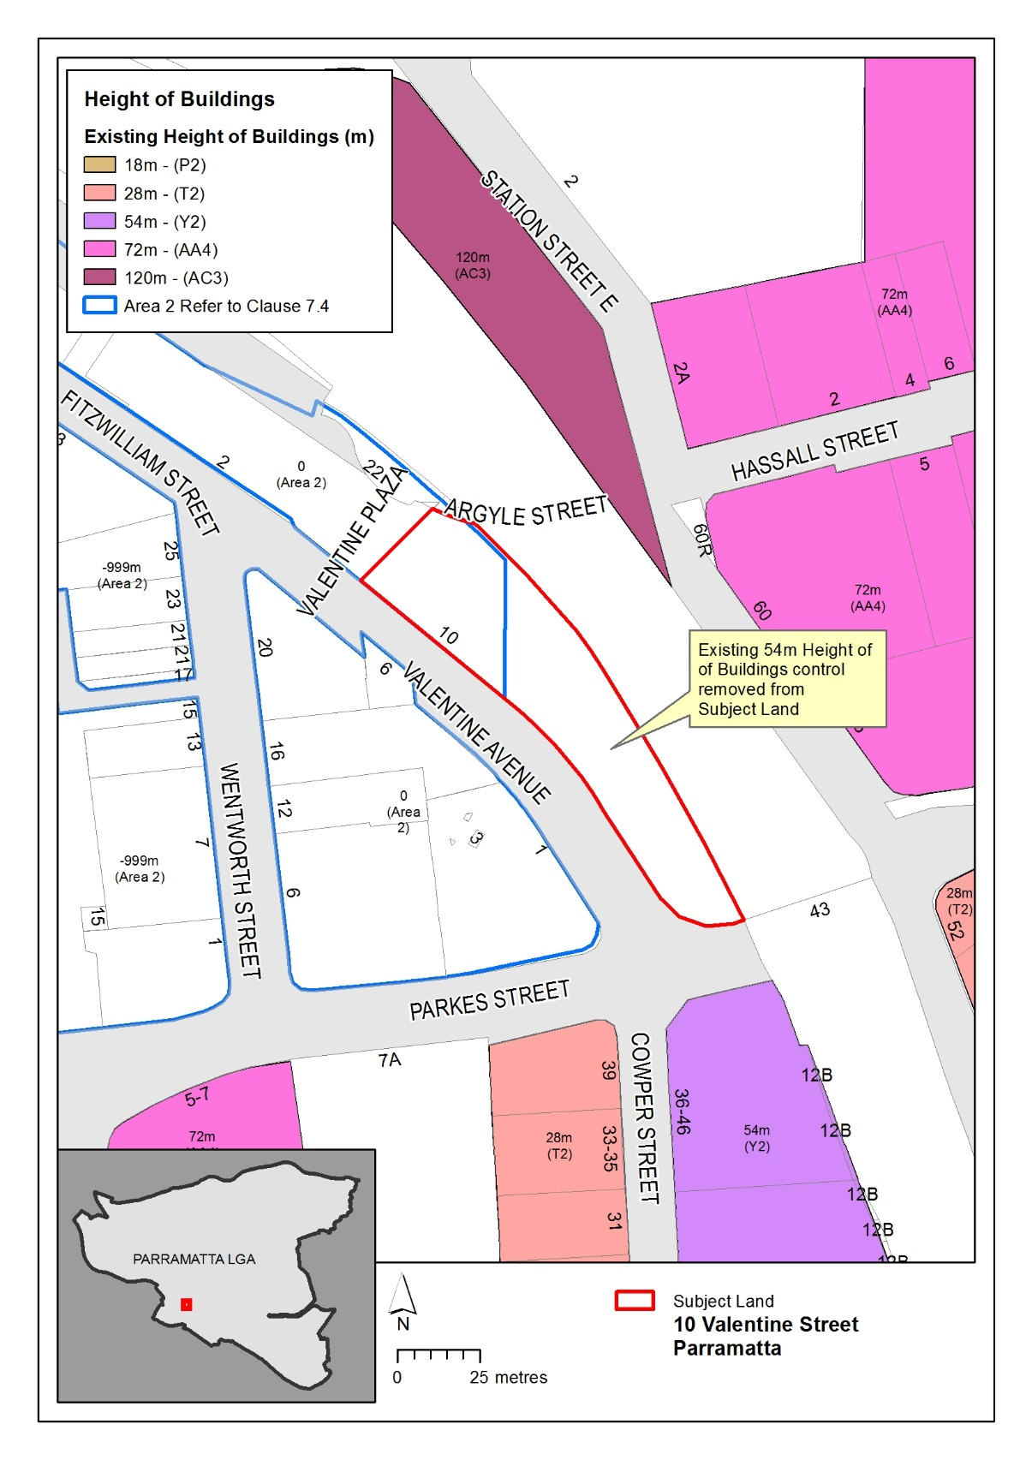

**Figure 13 –** Proposed amendment to the Parramatta LEP 2011 Height of Building Map

Figure 13 above illustrates the proposed removal of the height control over that part of the site that is currently subject to the 54 metre height control.

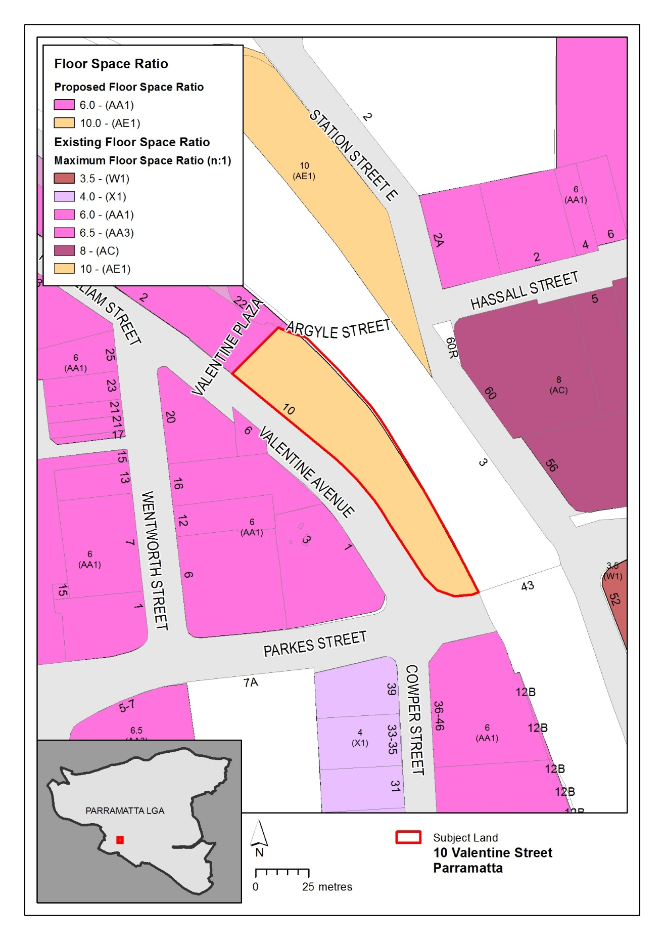

**Figure 14 –** Proposed amendment to the Parramatta LEP 2011 Floor Space Ratio Map

Figure 14 above illustrates the proposed FSR over the site. This excludes the additional 15% of GFA (which equates to a total FSR of 1.5:1 as this will be achieved through the forthcoming design excellence clause at development application stage.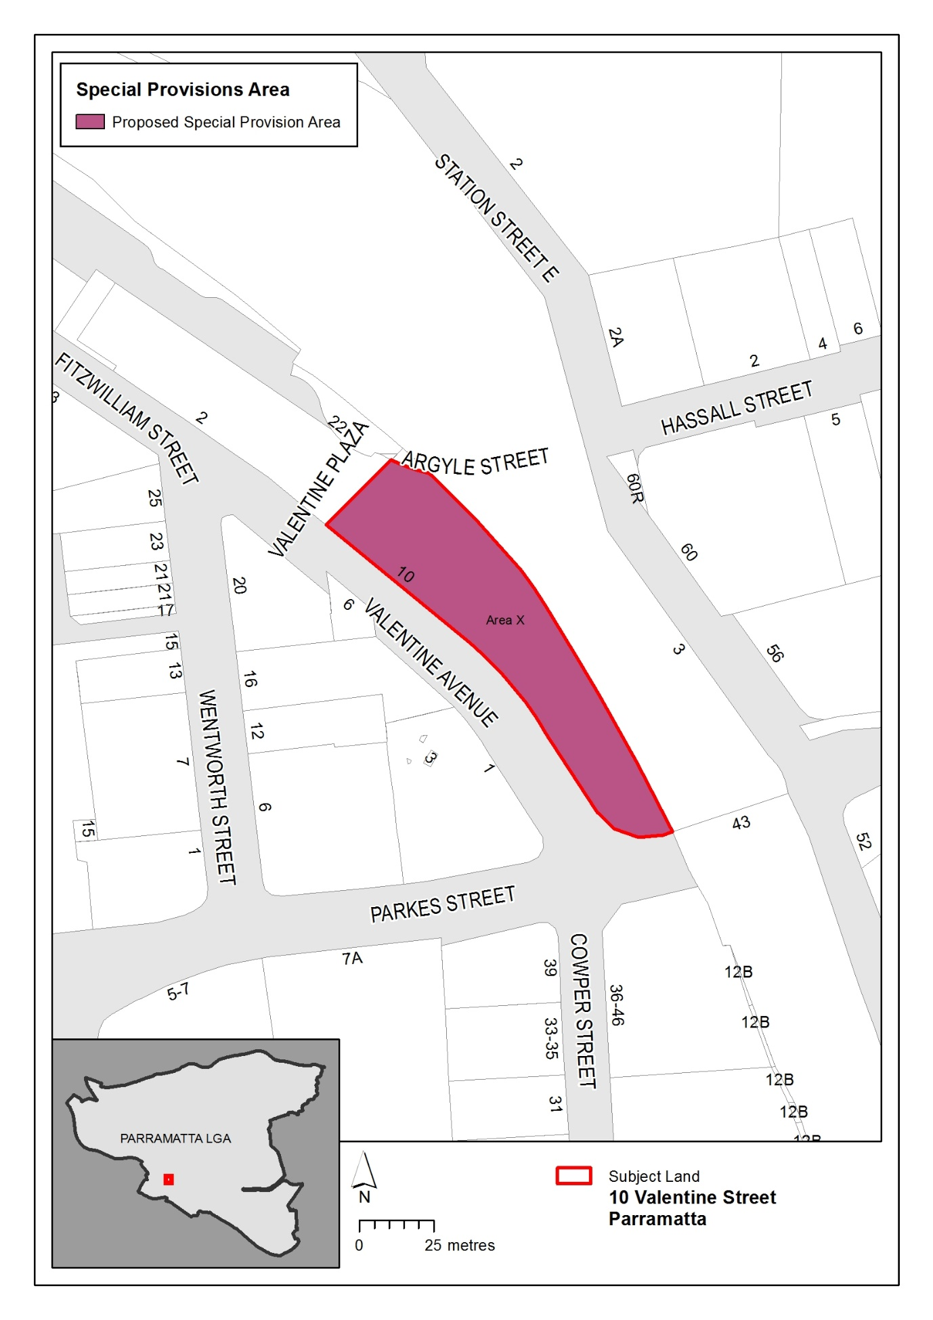

**Figure 15** – Proposed amendment to Parramatta LEP 2011 Special Provisions Map

Figure 15 above illustrates the proposed identification of the site on the Special Provisions Map.

# **PART 5 – COMMUNITY CONSULTATION**

The planning proposal (as revised to comply with the Gateway determination) is to be publicly available for community consultation.

Public exhibition is likely to include:

* newspaper advertisement;
* display on the Council’s web-site; and
* written notification to adjoining landowners.

The gateway determination will specify the level of public consultation that must be undertaken in relation to the planning proposal including those with government agencies.

Consistent with sections 3.34(4) and 3.34(8) of the *EP&A Act 1979*, where community consultation is required, an instrument cannot be made unless the community has been given an opportunity to make submissions and the submissions have been considered.

# **PART 6 – PROJECT TIMELINE**

The following steps are anticipated:

|  |  |
| --- | --- |
| **Milestone** | **Anticipated timeframe** |
| Report to LPP on the assessment of the PP | November 2018 |
| Report to Council on the assessment of the PP | December 2018 |
| Referral to Minister seeking Gateway determination | March 2019 |
| Issue of Gateway determination | May 2019 |
| Commencement and completion dates for public exhibition period | June 2019 |
| Commencement and completion dates for government agency notification | July 2019 |
| Consideration of submissions | July 2019 |
| Consideration of proposal post exhibition and reporting to Council | August 2019 |
| Submission to the Department to finalise the LEP | September 2019 |
| Notification of instrument | November 2019 |

# **Appendix 1 – Draft Site-Specific Clause**

***Potential draft clause to be included in the Parramatta LEP 2011.***

***Note: The Clause is draft only to demonstrate the intent of the clause and may be amended post-exhibition as part of the legal drafting process and prior to this amendment coming into force.***

*Part 7 Additional Local Provisions – Parramatta City Centre*

Clause 7.xx Development on land at 10 Valentine Macquarie Street, Parramatta

1. This clause applies to land at 10 Valentine Avenue, Parramatta, being Lot 2 Stratum Plan 1119257 and identified as area ## on the Special Provisions Area map.
2. The objectives of this clause are:

(a) to facilitate office premises on certain land in Zone B3 Commercial Core; and

(b) to prevent subdivision of above ground car parking;

(c) to prescribe car parking rates for the site that align with the Parramatta CBD Strategic transport Study.

1. Development for the purposes of office premises on land identified as “Area ##” on the [Special Provisions Area Map](http://www.legislation.nsw.gov.au/fragview/inforce/epi+650+2007+pt.5-cl.40+0+N?tocnav=y) is not subject to the floor space ratios specified under clauses 4.4, 7.2 or 7.15.
2. Development consent must not be granted to development on land identified as “Area XX” on the [Special Provisions Area Map](http://www.legislation.nsw.gov.au/fragview/inforce/epi+650+2007+pt.5-cl.40+0+N?tocnav=y) for the purpose of the subdivision of above ground parking.
3. The maximum car parking rates for any development proposed under this clause are as follows:
   1. The maximum car parking rates which apply to any part of the building used as a dwelling are:
      1. For each studio dwelling – 0.1 spaces, and
      2. For each 1 bedroom dwelling – 0.3 spaces, and
      3. For each 2 bedroom dwelling – 0.7 spaces, and
      4. For each 3 or more bedroom dwelling – 1 space.
   2. The maximum car parking rates for any part of a building used for the purposes of commercial or community uses is established by the following formula:

M = (G X A) / (50 X T)

Where:

M is the maximum number of parking spaces,

G is the gross floor area of all commercial and community uses in the building in square metres, and

A is the site area in square metres, and

T is the total gross floor area of all buildings on the site in square metres.

# **Appendix 2 – Urban Design Report**

Refer to separate attachment.

# **Appendix 3 – Draft Site-specific Development Control Plan**

Refer to separate attachment.



**Prepared by City of Parramatta**

